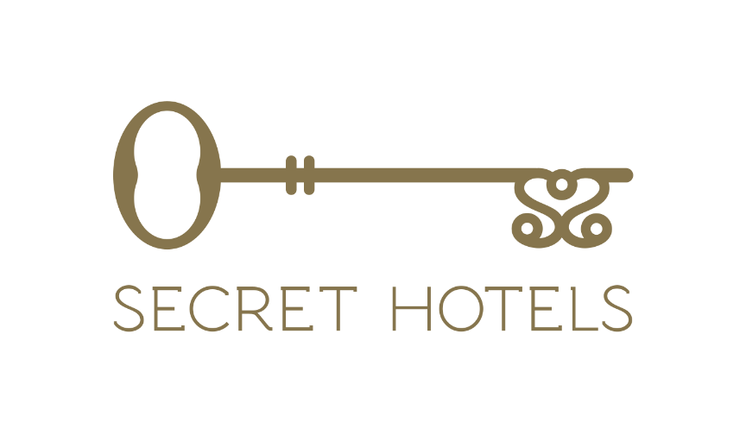
Have you ever dreamt of working in an idyllic location in the Aegean Sea? Well, you’re in luck because our Secret Hotels team in Oia, Santorini, is searching for new members for summer season 2024 starting in April.
Our Secret Hotels consists of 4 luxurious 5 star – properties: Santorini Secret Suites & Spa (proud member of Small Luxury Hotels of the World), Secret Legend Suites, Santorini Secret Premium in Oia, and Secret View in Foinikia, Santorini.
The Secret Hotels gives you the opportunity to develop your skills and excel in your career by becoming part in one of the most luxury hotels in Santorini.
Join the team and discover the "SECRET" of Greek hospitality.

Please contact us by e mail : hr@santorini-secret.com
Or by phone: +30 6980475666 (Lamprakis Michail Hotel Manager)

